Technical Implementation of a Software Product

Course: | 4A00EZ64-3003/3004 Monialainen projektityö
Product: | A calculator for gearbox sustainability
When implemented? | 1.10.2025-12.12.2025
Members of the project team: | Lassi Kivirikko(IT), Kasperi Kukkamäki (IT), Arttu Saarela(IT), Santeri Jussila (IT), Sophie Gerich (Business), Luca Seitz (Business), Sebastian Moosbrugger (Business), Josephine Jäkel (Business), Sarah Neuner (Business), Stephie Zillner (Business), Elizabeth Howell (Business)
Client/customer: | Markus Klein

Version History of this Document
Date | Modified by | Description of Changes
30.11.2025 | Lassi Kivirikko | The first draft
12.12.2025 | Lassi Kivirikko | The final version
- Product
  - Product Description
A Website that allows you to calculate the emission, costs and social impact score of gearboxes.
  - Other Documentation
Website link: http://51.20.1.87/
  - Code etc. Availability
The React Vite full stack in running on a AWS EC2 instance with a linked in AWS RDS for the database. Only people with the AWS account credentials can access the instance.
  - Relevant Addresses to Access the Product
Website link: http://51.20.1.87/
- Implementational Decisions Made
  - Constraints, Demands, and Justifications for the Decisions
The data stored into the website is semi sensitive according to the client. So we needed to implement a login page to make sure that only people, who know the password can access the website. The database should not be visible to anyone who doesn’t know the password.
  - Languages, Libraries, and Tools Used.
Languages used: React, JavaScript, HTML, CSS
- User Roles
The website only has one role. It is more of an administrative role, because you are able to delete and update the database when you are in the website. If you want to make code changes, you need access to the EC2 instance.
- Data Protection and Data Security
For data security we have put all the sensitive information in the code to .env files. Currently the EC2 instance doesn’t have any backups. So, if the AWS region goes down, the data is possibly erased. Also, as of now there is a known issue, where you can bypass the login page by typing the url as /saved results

- Architectural Overview of the System / Operating Environment
The project is done using React vite structure. All the frontend code files are under /src. There is also a backend folder for all the routes, database creation, schemas etc. The app is run inside an EC2 instance with nginx serving the static files of the website. The backend is run on the EC2 via systemd that starts at boot. It runs node index.js that activates the backend for the duration of the runtime. It connects to an AWS RDS (Relational Database Service) using a .env file that has the username, password and the host IP of the RDS. Because of the RDS security group rules, only the EC2 instance can access the database so it is good for security. It is a simple way to run the website, when the scale and complexity of the processes is modest. This way also makes sure that CORS is not a problem.
- Code Structure
The code itself is using a pretty standard React Vite fullstack model. It has all the frontend code under /src directory and all the backend under GreenGear-backend folder. Each view of the website has a .jsx file attributed to it. For example, the calculator view has its own file Calculator.jsx. In React Vite the App.jsx is the main file that all the other components branch out of. Main.jsx renders the app component and creates static files so that the website can run properly.
- Data Storage Solutions
The system uses PostgreSQL as the sole database management system, with a managed Amazon RDS instance in production (server version governed by RDS and not pinned in the codebase), accessed from Node.js via the official PostgreSQL driver pg. (version ^8.16.3). The schema is relational and centres on the gearbox table that has gearbox lifecycle data. Materials, manufacturing, transportation and other related data have their own tables that linked to the gearbox table via the gearbox_id value. An environmental file (.env) has all the RDS credentials loaded safely and all database access flows through Express API endpoints with CORS enabled.
Gearbox table creation command:
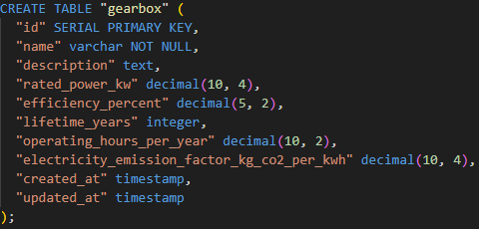
- Maintenance
  - Responsabilities and Maintenance Processes
Who is responsible for what when the system is run/maintained? On which organizational protocols or processes is this division based? (E.g., if an end user requires his/her user information to be removed from personal data registries, is there in use some clear and documented process about how to handle this? How is this reflected on the maintenance work?)

  - Installation
The system itself is possible to test in local mode. So, if you download the relevant code and install the packages, you can run the code with npm run. So download the code, go to /greengear-calculator directory and do npm install + npm run to get the website up in localhost. However, this does not change the cloud version. For that you would need to go into the EC2 instance and for that you need an SSH into the instance like this (ssh -i "your-key.pem" ec2-user@your-instance-public-dns) you can find the ssh key from EC2 key pairs section but you will need the corresponding AWS account credentials for that.
  - Stopping and Starting the Operations, Making Backup Copies and Restoring the System, and Emergency Procedures

The RDS and EC2 instances have backup snapshots in case anything happens to them so from the you can restore both of them.
For maintenance in the cloud some of the most critical commands are surrounding the backend. Here are some of the most important commands (these commands can only be executed inside the EC2 instance):
To stop the backend API and nginx
sudo systemctl stop greengear-api.service; sudo systemctl stop nginx
To start the backend API and nginx if they are stopped
sudo systemctl start greengear-api.service; sudo systemctl start nginx
To restart the backend API and nginx (must be done when updates to the code are made)
sudo systemctl restart greengear-api.service; sudo systemctl restart nginx
To show logs of the backend
sudo journalctl -u greengear-api.service -n 200 -f

  - Changing the code and changing the Cloud
The current version of RDS in AWS is a free tier that expires in 12 months. After that time, it starts charging a fee. The AWS account was given by the Munich professors in the project, so we don’t know if this is going to be a problem in the future. If you have the code locally, it is easy the update it and see the changes live if using npm run dev command when running the website. In the cloud updates can rolled in the EC2 instance by going to the prototype directory and using git pull to pull all of the new features. After that you need to build the application again using npm run build. Then you need to replace the static files nginx is serving by doing sudo rm -rf /usr/share/nginx/html/* and sudo cp -r dist/* /usr/share/nginx/html/ Last to update the website itself you need to restart nginx by doing
sudo systemctl restart nginx Now the website is updated in the cloud.
  - Logging, Reports, and Monitoring
For monitoring, the AWS EC2 and RDS have monitoring tab that gives information about the data usage and network traffic in and out. In the EC2 instance you can also see logs of backend logins, errors and other notes. We felt that for this kind of application these kinds of logs/reports were sufficient.
- Instructions for Basic Usage
First you go to http://51.20.1.87 then you will need to login
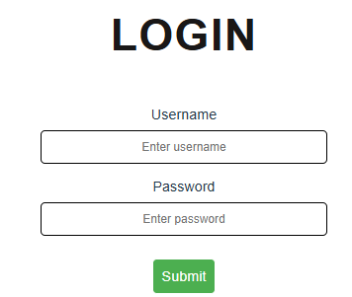
Currently the username is admin and the password is adminpass. The however can be changed if Markus Klein decides to change the password. When you are in, you see the calculator page. You can input data into the fields, and it will calculate the results in the results box
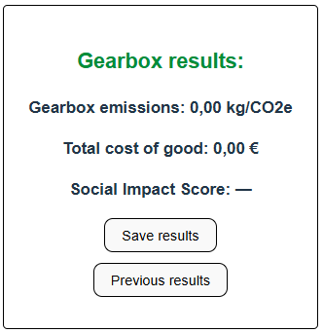
In the social impact calculator you can input a country and it will read that countries score from a csv file containing the current scores. So you can input “Germany” and it will give you the score of Germany. For multiple countries, it will take the average score.

After inputting data, you can save the results, and it will be saved in the database. Previous results show you all the calculation results previously done. In the results tab you can see all the current gearboxes in the database. You can view each of the gearboxes, which gives you a more detailed look of the values used in the calculation. You can update the values by inputting a new value and pressing update values at the bottom of the view if the value was missing it will show that, so the user knows that it was not considered in the calculation

Example of a missing field and a field with data. User can input new data in the input field.
There are also graphs for the CO2 emissions and cost calculations that visualize the data in a better manner.
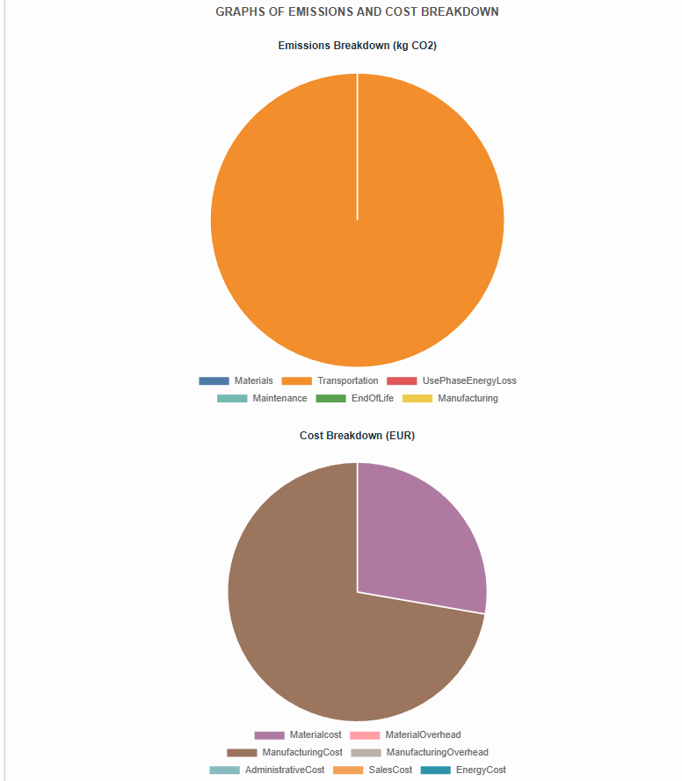
At the bottom of the view there are buttons for updating values and exporting pdf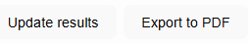
Export PDF that makes a pdf that has the data in this format:
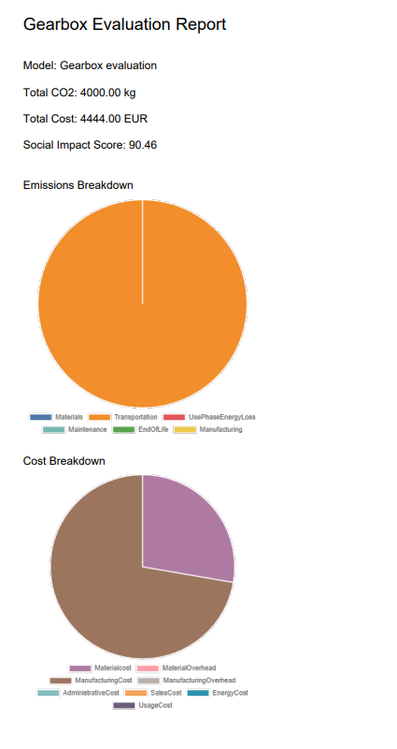

If you go back to the calculator view, you can see 3 buttons in the top right.
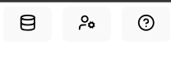
The question mark gives you information about the usage, data source etc. The middle button gives you an opportunity to change the password. And the first button allows you create material dataset. Because we couldn’t get data on materials (market price, emissions per kg) we can create datasets to where the user can just choose a material in the calculator page and it will hold those values
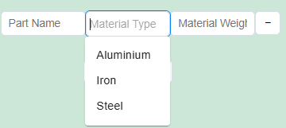
You can see the current materials in the materials view
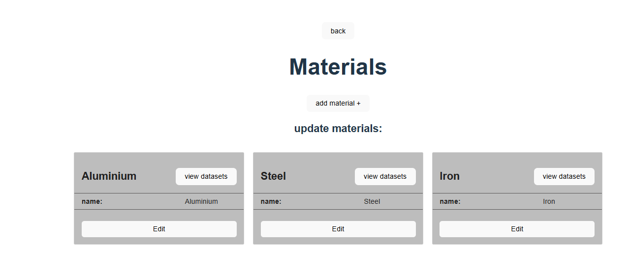You can add or delete a material if needed. From the view datasets button, you can see the values each material holds. For example, in this case steel holds these values:
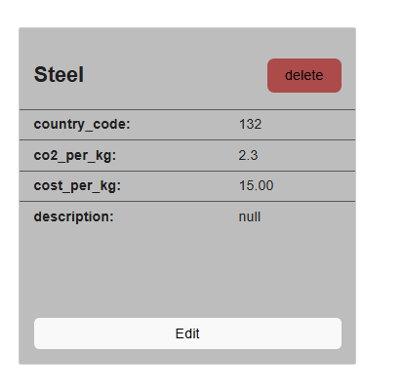
You can add more than one dataset to material. For example, if you have data for steel from 2 different countries.

- Missing Features, Known Problems, and Future Development
There could be some further developments for the datasets, possibly adding additional values there, adding other graphs to visualize the results better. Some stylistic elements are a bit off as well (text placements misalign etc.) Further development of the tool is possible, but the specifics would need to be discussed with Mr. Klein. Otherwise we can offer him advice on how to continue.

